1) GPA - numerical, actual GPA

2) Gender (1 - Female and 2 - Male)

3) Breakfast (the participants are shown the following pictures and asked which one of these pictures they associate with the word “breakfast), 1 - cereal option and 2 - donut option

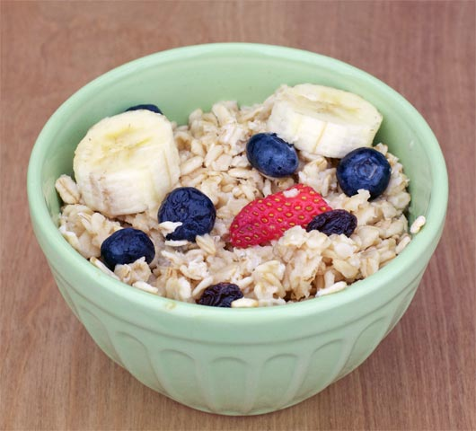



4) calories_chicken - guessing calories in chicken piadina:

1 - 265

2 - 430

3 - 610

4 - 720

(the variable shows the actual number of calories participants selected)

5) calories_day - Importance of consuming calories per day

1 - i dont know how many calories i should consume

2 - it is not at all important

3 - it is moderately important

4 - it is very important

6) calories_scone - Guessing calories in a scone from starbucks

1 - 107 cal

2 - 315 cal

3 - 420 cal

4 - 980 cal

(the variable shows the actual number of calories participants selected)

7) coffee - which of the two pictures you associate with the word coffee?

1 - creamy frapuccino shown

2 - espresso shown





8) comfort_food - List 3-5 comfort foods that come to mind.

Open ended (perfect for NLP)

9) comfort_food_reasons - What are some of the reasons that make you eat comfort food? (i.e., anger, sadness, happiness, boredom, etc) - list up to three

Open ended (perfect for NLP)

10) comfort_food_reasons_coded

(the one mentioned first)

1 - stress

2 - boredom

3 - depression/sadness

4 - hunger

5 - laziness

6 - cold weather

7 - happiness

8- watching tv

9 - none

11) cook - how often do you cook?

1 - Every day

2 - A couple of times a week

3 - Whenever I can, but that is not very often

4 - I only help a little during holidays

5 - Never, I really do not know my way around a kitchen

12) cuisine - what type of cuisine did you eat growing up?

1 - American

2 - Mexican/Spanish

3 - Korean/Asian

4 - Indian

5 - American inspired international dishes

6 - other

(lots of cleaning needed for this variable)

13) diet_current - describe your current diet

open ended - ideal for NLP

14) diet_current_coded

(based on words used to describe the diet)

1 - healthy/balanced/moderated/

2 - unhealthy/cheap/too much/random/

3 - the same thing over and over

4 - unclear

15) which picture do you associate with the word “drink”?

1 - orange juice

2 - soda

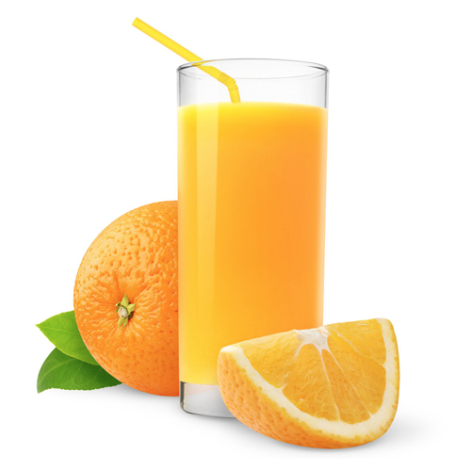

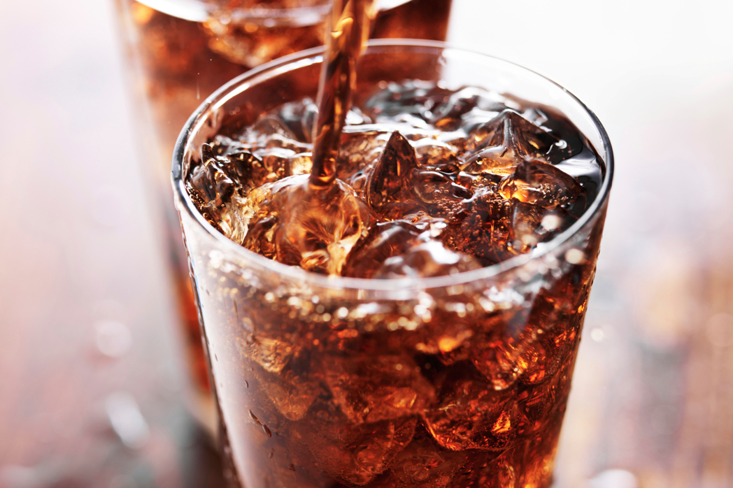

16) eating_changes - Describe your eating changes since the moment you got into college?

Open ended

17) eating_changes_coded

1 - worse

2 - better

3 - the same

4 - unclear

18) eating_changes_coded1

1 - eat faster

2 - bigger quantity

3 - worse quality

4 - same food

5 - healthier

6 - unclear

7 - drink coffee

8 - less food

9 - more sweets

10 - timing

11 - more carbs or snacking

12 - drink more water

13 - more variety

19) eating_out - frequency of eating out in a typical week

1 - Never

2 - 1-2 times

3 - 2-3 times

4 - 3-5 times

5 - every day

20) employment - do you work?

1 - yes full time

2 - yes part time

3 - no

4 - other

21) ethnic_food - How likely to eat ethnic food

1 - very unlikely

2 - unlikely

3 - neutral

4 - likely

5 - very likely

22) exercise - how often do you exercise in a regular week?

1 - Every day

2 - Twice or three times per week

3 - Once a week

4 - Sometimes

5 - Never

23) father_education -

1 - less than high school

2 - high school degree

3 - some college degree

4 - college degree

5 - graduate degree

24) father_profession - what is your father profession?

Open ended

25) fav_cuisine - What is your favorite cuisine?

Open ended

26) fav_cuisine_coded

0-none

1 - Italian/French/Greek

2 - Spanish/Mexican

3 - Arabic/Turkish

4 - Asian/Chinese/Thai/Nepal

5 - American

6 - African

7 - Jamaican

8 - Indian

27) fav_food - was your favorite food cooked at home or store bought?

1 - cooked at home

2 - store bought

3 - both bought at store and cooked at home

28) food_childhood - what was your favorite childhood food?

Open ended

29) which of these pictures do you associate with word fries?

1 - Mcdonald’s fries

2 - home fries

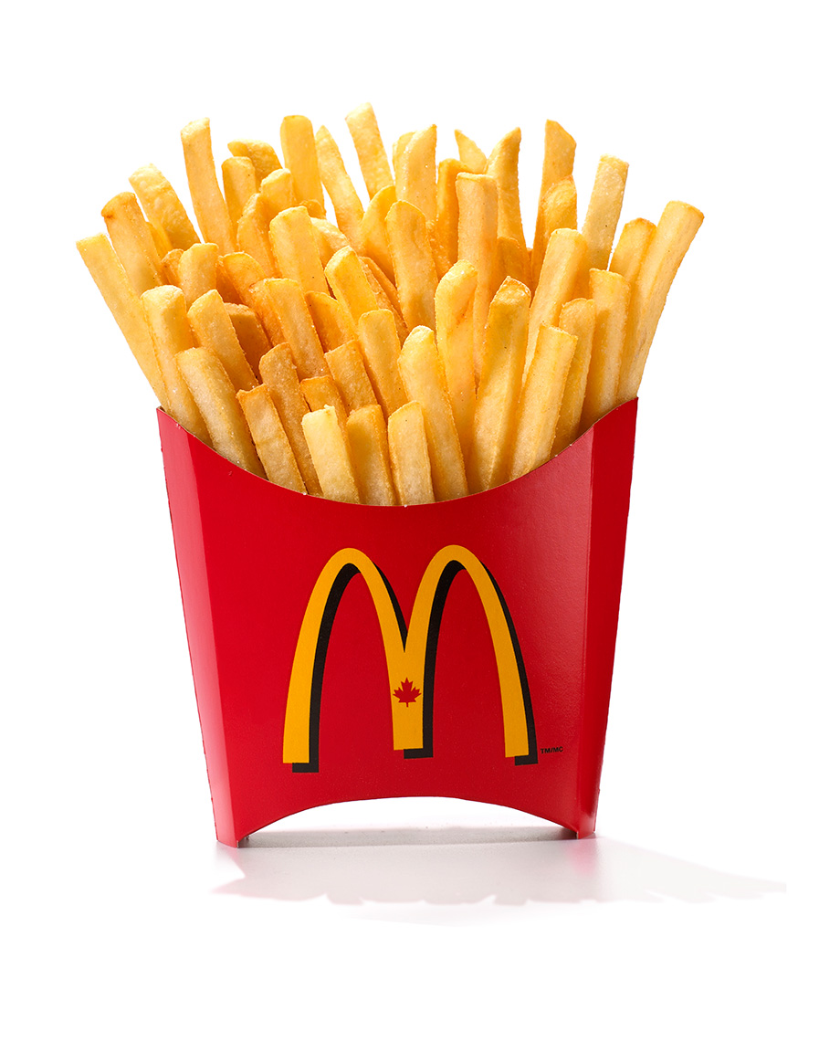

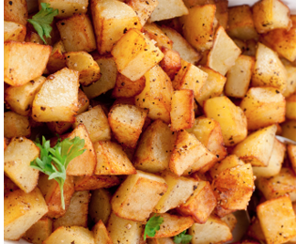

30) fruit_day - How likely to eat fruit in a regular day

1 - very unlikely

2 - unlikely

3 - neutral

4 - likely

5 - very likely

31) grade_level -

1 - freshman

2 -Sophomore

3 - Junior

4 - Senior

32) greek_food - How likely to eat Greek food when available?

1 - very unlikely

2 - unlikely

3 - neutral

4 - likely

5 - very likely

33) healthy_feel - how likely are you to agree with the following statement: “I feel very healthy!” ?

1 to 10 where 1 is strongly agree and 10 is strongly disagree - scale

34) healthy_meal - what is a healthy meal? Describe in 2-3 sentences.

Open ended

35) ideal_diet - describe your ideal diet in 2-3 sentences

Open ended

36) Ideal_diet_coded

1 - portion control

2 - adding veggies/eating healthier food/adding fruit

3 - balance

4 - less sugar

5 - home cooked/organic

6 - current diet

7 - more protein

8 - unclear

37) income

1 - less than $15,000

2 - $15,001 to $30,000

3 - $30,001 to $50,000

4 - $50,001 to $70,000

5 - $70,001 to $100,000

6 - higher than $100,000

38) indian_food - how likely are you to eat Indian food when available

1 - very unlikely

2 - unlikely

3 - neutral

4 - likely

5 - very likely

39) Italian_food - how likely are you to eat Italian food when available?

1 - very unlikely

2 - unlikely

3 - neutral

4 - likely

5 - very likely

40) life_rewarding - how likely are you to agree with the following statement: “I feel life is very rewarding!” ?

1 to 10 where 1 is strongly agree and 10 is strongly disagree - scale

41) marital_status

1 -Single

2 - In a relationship

3 - Cohabiting

4 - Married

5 - Divorced

6 - Widowed

42) meals_dinner_friend - What would you serve to a friend for dinner?

Open ended

43) mothers_education

1 - less than high school

2 - high school degree

3 - some college degree

4 - college degree

5 - graduate degree

44) mothers_profession - what is your mother’s profession?

45) nutritional_check - checking nutritional values frequency

1 - never

2 - on certain products only

3 - very rarely

4 - on most products

5 - on everything

46) on_off_campus - living situation

1 - On campus

2 - Rent out of campus

3 - Live with my parents and commute

4 - Own my own house

47) parents_cook - Approximately how many days a week did your parents cook?

1 - Almost everyday

2 - 2-3 times a week

3 - 1-2 times a week

4 - on holidays only

5 - never

48) pay_meal_out - How much would you pay for meal out?

1 - up to $5.00

2 - $5.01 to $10.00

3 - $10.01 to $20.00

4 - $20.01 to $30.00

5 - $30.01 to $40.00

6 - more than $40.01

49) Persian_food - How likely to eat Persian food when available?

1 - very unlikely

2 - unlikely

3 - neutral

4 - likely

5 - very likely

50) self_perception_weight - self perception of weight

6 - i don’t think of myself in these terms

5 - overweight

4 - slightly overweight

3 - just right

2 - very fit

1 - slim

51) Which of the two pictures you associate with the word soup?

1 - veggie soup

2 - creamy soup

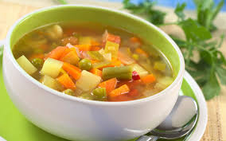

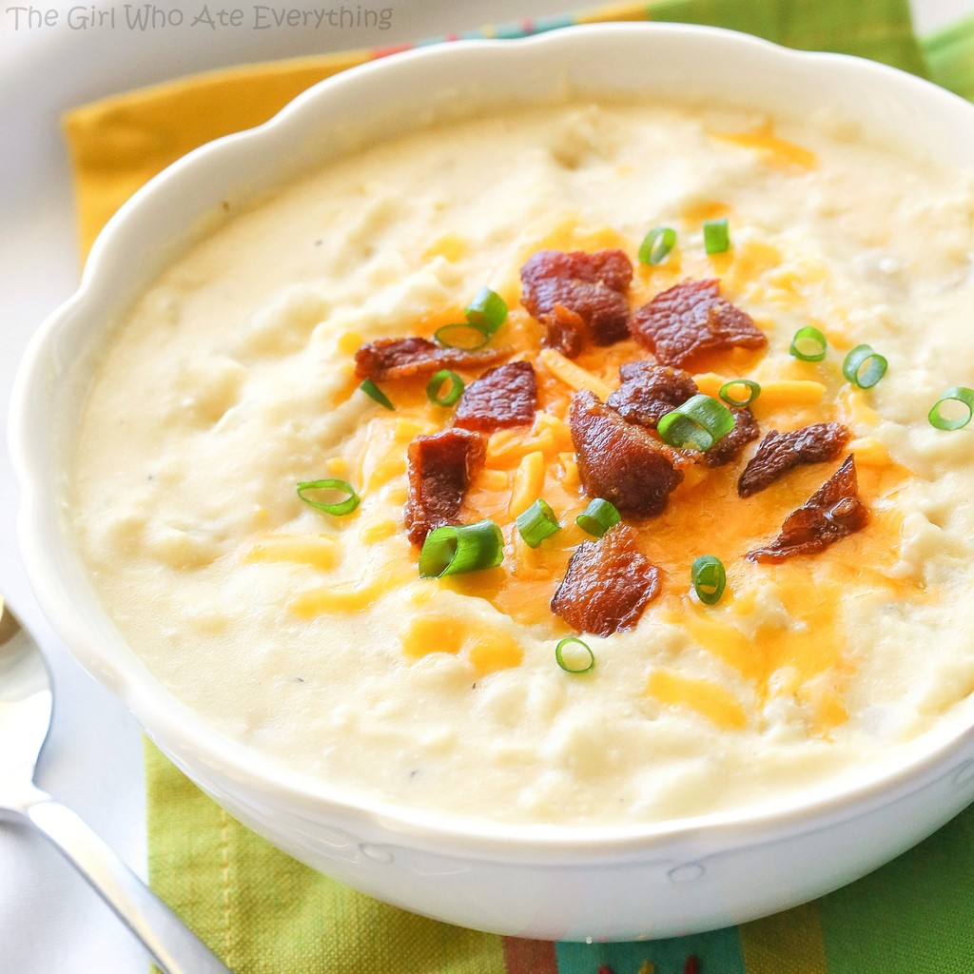

52) sports - sports - do you do any sporting activity?

1 - Yes

2 - No

99 - no answer

53) thai_food - How likely to eat Thai food when available?

1 - very unlikely

2 - unlikely

3 - neutral

4 - likely

5 - very likely

54) tortilla_calories - guessing calories in a burrito sandwich from Chipotle

1 - 580

2 - 725

3 - 940

4 - 1165

55) turkey_calories - Can you guess how many calories are in the foods shown below? (Panera Bread Roasted Turkey and Avocado BLT)

1 - 345

2 - 500

3 - 690

4 - 850

56) type_sports - what type of sports are you involved?

Open-ended

57) veggies_day - How likely are you to eat veggies in a day?

1 - very unlikely

2 - unlikely

3 - neutral

4- likely

5 - very likely

58) vitamins - do you take any supplements or vitamins?

1 - yes

2 - no

59) waffle_calories - guessing calories in waffle potato sandwich

1 - 575

2 - 760

3 - 900

4 - 1315

60) weight - what is your weight in pounds?